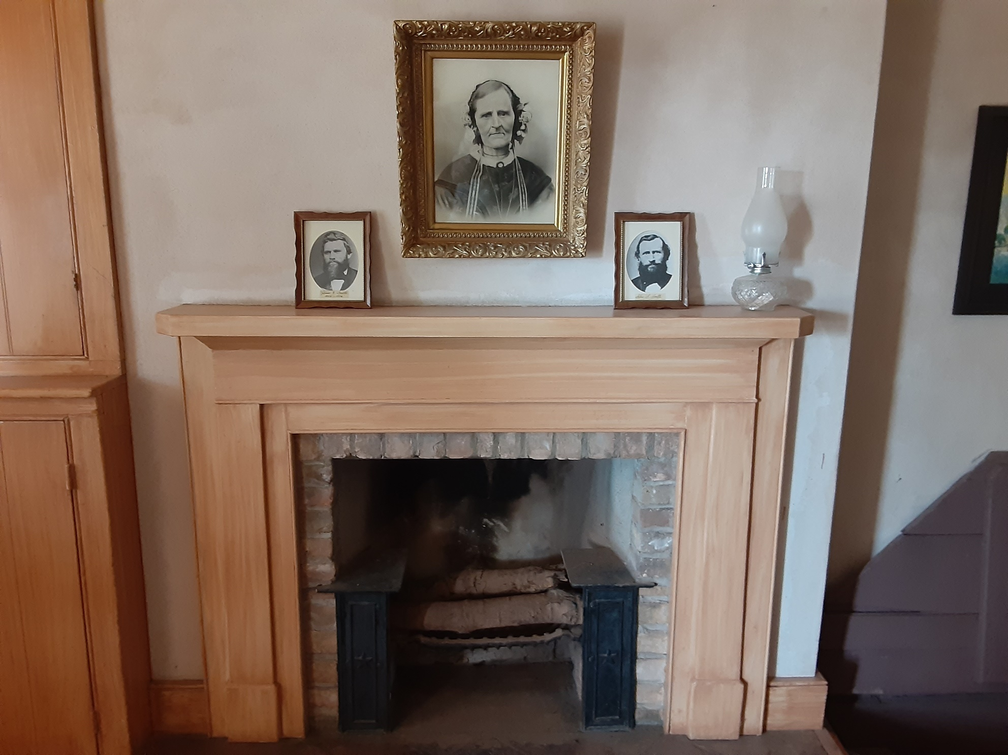

**4th Grade Ancestor Essays, 2022**

|  |  |
| --- | --- |
| **East Elementary**   * **1st Place: Joseph Cosslett** * **2nd Place: Gerald Gillins** * **3rd Place: Carl William Stine**   **Enoch Elementary**   * **1st Place: Pauline Martinsen Bagley** * **2nd Place: Martha Henrietta Lunt Jones** * **3rd Place: Robert Troy Jensen** * **Dora Margaret Heppley Strasser** * **Elliot Miles Barney** * **Ethel Lakay Quilter** * **James Daniel Murphy** * **Minerva Pearl Hatch** * **Randall Phillips** * **Robert Jacob Jamsa** * **Ronald Ray Meachum** * **Roy Evan Stapp** * **Small Step Big Leap** * **William Slade** * **Zoella Palmer Benson**   **Fiddlers Canyon Elementary**   * **1st Place: Charles Bennett Maxwell** * **2nd Place: Riley Jensen** * **3rd Place: Grandma and Grandpa** * **My Awesome Ancestor** * **Ann Loader Dalling Paul** * **CCA Christensen** * **Chuck** * **Howard Clair Heninger** * **Mitzi Boston Davis**   **Gateway Elementary**   * **1st Place: Thomas Mowery** * **2nd Place: John Riggs Murdock** * **3rd Place: Daniel Richard Dail** * **Charlotte Mary Burgoyne Thompson** * **Sherrie Ann Carnesecca** | **Iron Springs Elementary**   * **1st Place: Josephine Tomine Fredericksen Torgersen** * **2nd Place: Melvin Reed Crossley** * **3rd Place: Grandma Willie** * **About Levi Stewart** * **Bengi Carter** * **Frank Martin** * **Grandma Barb** * **Herman Dagget Bayles** * **Jack Cleon Reber** * **James Hoyle** * **Kenneth Gene Butler** * **Leslie William Parker** * **Levi Stewart** * **Mark Losee** * **Nathaniel Gardner** * **Orrin Millett** * **Patricia Ruth Cassidy** * **Paul Christain Brown** * **Richard Kenneth Benson** * **Robert Jay Holt** * **Vicki Ebert**   **North Elementary**   * **1st Place: Gladys Denetclaw Daniel** * **2nd Place: Henry Lunt** * **3rd Place: Refugio Figueroa** * **Arthur Porter** * **Charles Joseph Manuele** * **Cheryl Baker Ross** * **Conneth Lee Dunson** * **David Arial Westover** * **Dennis Mark Gray** * **Edward Winslow the Soup Guy** * **Evelyn Joyce Brister Carter** * **Gwen Monroe** * **Herbert Henry Nakken** * **Jay Allen May** * **Jennifer Stafford** |
| **North Elementary (continued)**   * **John Toone** * **Joyce K Thorson Morgan** * **Lisa Kay Pellegrini** * **Louise Liston** * **Lynn Stevens Kearsley** * **Maria Wadalupe Samano** * **Mark Robert Hontz** * **Robert Thomson** * **Ruby Fern Boward** * **Walt Disney**   **South Elementary**   * **1st Place: Oliver Tsinnie** * **2nd Place: Sarah Thompson Phelps** * **3rd Place: Henry C. Esplin** * **Joyce Esplin Wasden** * **Afton Pollock** * **Arthur Dee McAllister** * **Aunt Pliny** * **Bud Lawrence Albert Rember** * **Evelyn Welch** * **Frank John Bali** * **Jasper Martell Bird** * **John B Swain, respectful fugitive** * **Kichi Murakami** * **Otto Fife** * **Roger Fin Williams** | **Three Peaks Elementary**   * **1st Place: Glen Dale Jorgenson** * **2nd Place: Hole in the Rock Holyoak** * **3rd Place: Ellen Garn Capner Rhodes** * **Gary Clarence Hugie** * **Jens Christen Christensen** * **Lane Joseph Bertelsen** * **Lydia Knight** * **My Building Grandpa** * **My Grandpas Story** * **New Whitney** * **Owen Sanders** * **William Baley Maxwell** |