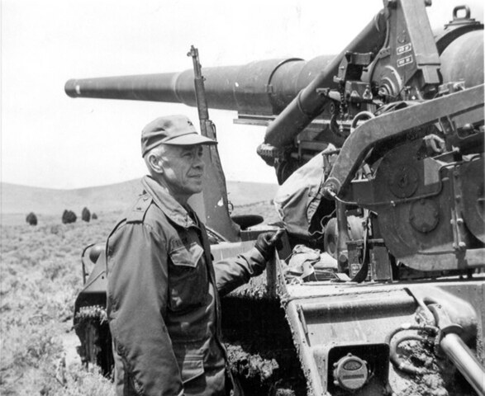

*Frank Dalley served with the Utah National Guard or on active duty for 33 years, retiring as Brigadier General in 1971.*

**Historical Threads**

**Frank Dalley, American Hero**

**By Jay M. Jones**

Frank Dalley was born in Panguitch, Utah and lived in Summit much of his life. He graduated from the Branch Agricultural College (now SUU) in 1935 and began teaching in the Iron County School District the following fall.

Frank married his high school sweetheart, Mary Gardiner, in 1936. He later joined the National Guard and became an officer.

In March 1941 the Southern Utah National Guard was activated into federal service and sent to San Luis Obispo, California for training. Frank was transferred to an assignment in the South Pacific in 1942.

He was promoted to the rank of Major in the army. The 30 November 1944 issue of the Iron County Record included a note about Major Dalley: “For the past eight months he has been helping to make escape proof the trap which surrounds the Japanese garrison at Rabaul on New Britain in the Southwest Pacific.”

About 100,000 Japanese military personnel were located at Rabaul, in what is now Papua New Guinea. A direct attack to overtake Rabaul would have been very costly in blood and treasure, so the decision was made to bypass it. It was necessary to block the Japanese garrison there so they would not be able to sustain a significant attack on the Allied forces advancing in other directions.

Major Dalley’s experience in helping to plan the successful isolation of Rabaul provided experience in strategy and tactics that he carried with him to his future assignment in Korea. He also gained experience at Guadalcanal and the Philippines.

Following another promotion and his military service throughout World War II, Lieutenant Colonel Frank Dalley began a civilian career with the Utah State Employment Service. He continued serving in and leading the 213th Field Artillery Battalion of the Utah National Guard headquartered at Cedar City.

In June 1950, North Korea attacked South Korea. Seoul, the capital of South Korea, was overrun. The United States and other Allied nations sent troops to help defend South Korea in July 1950.

The 213th was called to active duty in August and orders were given to report at Fort Lewis, Washington, where their numbers were increased to full battalion strength with the addition of men and officers from the regular army.

In the meantime, General Douglas MacArthur led American forces into North Korea in October, and the Chinese responded with massive numbers of troops sent to bolster the North Korean war machine in November 1950.

After training at Fort Lewis, the 213th arrived in Korea in February 1951. The Chinese launched a major offensive in the Spring of 1951, and the 213th was assigned to the battle front near Kapyong in April 1951.

In the Battle of Kapyong (also spelled Gapyeong) in April 1951, Allied forces from Canada, Australia, New Zealand and the United States slowed down the Chinese advance. The 213th played a supporting role in this battle, its first combat action in Korea.

Although the Allies had prevented a disastrous breakthrough by the Chinese, they were forced to withdraw to the south. The 213th was the last of the artillery units to withdraw, overcoming a dangerous threat of being trapped by the enemy.

A few years later, Colonel Dalley related some of these experiences on a radio program by Edward R. Murrow called “This I Believe”, broadcast nationally on 15 January 1954. The recording can be found at <https://dl.tufts.edu/concern/audios/2z10x136b/>

After a couple of weeks rest, the 213th was sent back to the Gapyeong area in May, and experienced what has been called “The Miracle at Gapyeong”. Quoting from a Distinguished Unit Citation by Major General Wyman presented to the 213th for their action on May 26 and 27:

“A force of approximately 4,000 enemy soldiers . . . attempted to break out of its trap and rejoin the main body of the enemy army. The only escape route open to them led directly through the valley occupied by [the 213th].”

According to Klien Rollo, a member of the 213th writing for the Iron County Record, during the period from May 23 to May 29 the 213th captured 976 prisoners of war and inflicted approximately 451 casualties on the enemy. Four men of the 213th were injured, but none were killed.

Colonel Dalley returned to the United States in January 1952 and remained on active duty with an assignment at Camp Carson in Colorado. He was released from active duty in June 1952 and returned to his service with the Utah National Guard.

Frank Dalley retired from the Utah National Guard as a Brigadier General in November 1971. He died 8 April 1990 in Cedar City.

In the 1960’s an elementary school class toured the National Guard armory at Cedar City, and the teacher introduced Frank Dalley as an American hero. He said he didn’t know about being a hero, but that he always tried to be a good citizen. He told the young students that every one of them could be a good citizen.

Frank Dalley led a well-trained Army Battalion through chaotic combat conditions. His men followed him because he had earned their trust. And they all came home. Whether he would acknowledge it or not, Frank Dalley is a true American hero.