**Historical Threads, Iron County Today**

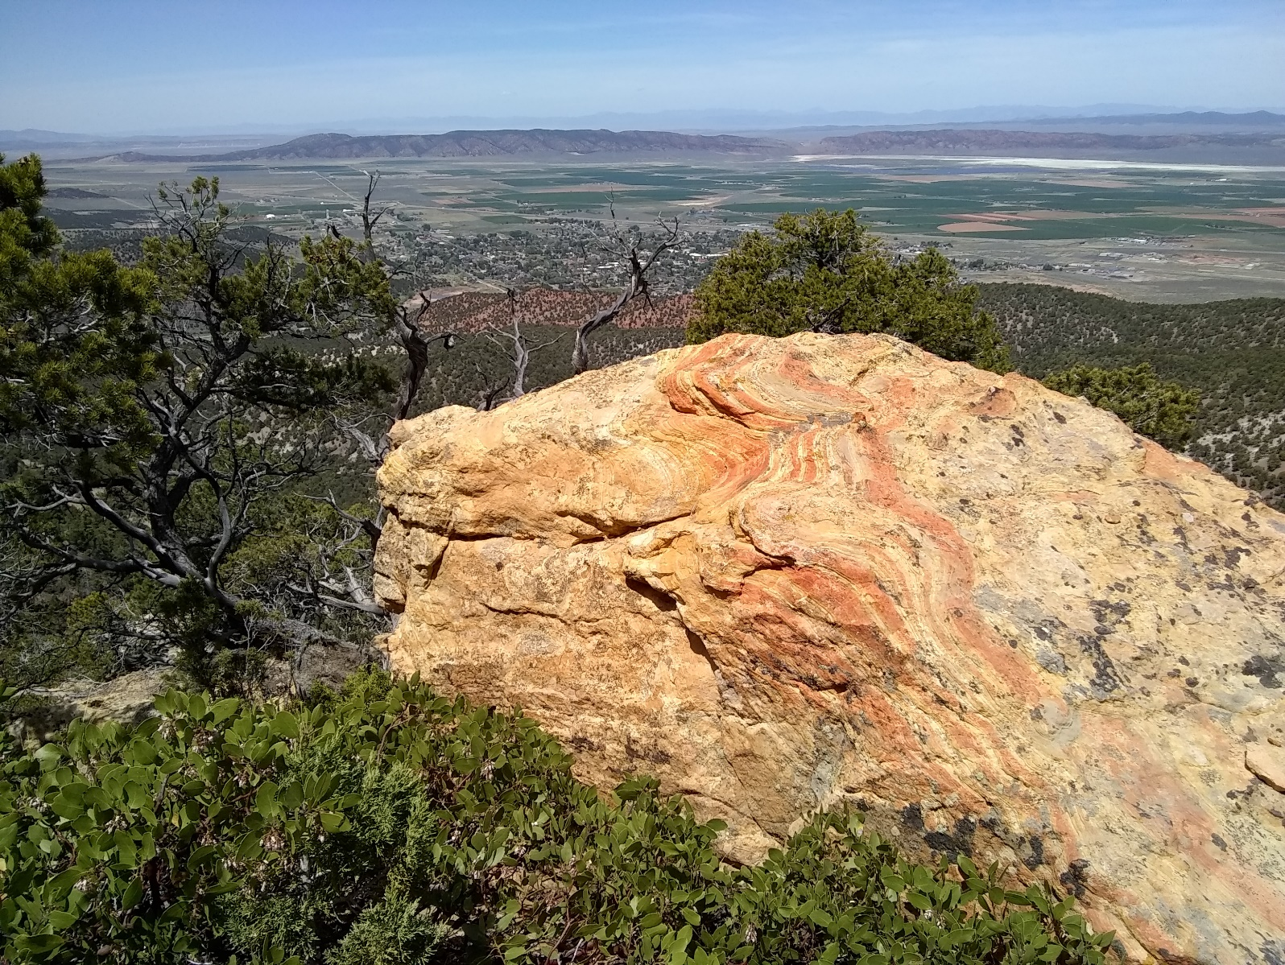

|  |  |  |
| --- | --- | --- |
| [Dominguez-Escalante](C:\\Users\\jayjo\\OneDrive\\Documents\\SUP\\IC_Today\\Dominguez-Escalante.pdf)  Death Valley 49ers  Cedar City Christmas 1852  Rachel Harris  Carvalho Visits Iron County  Search for Refuge, Part I  Search for Refuge, Part II  Lorenzo and Susannah Roundy  Priddy Meeks  James Martineau, Railroad Surveyor  John Wesley Powell, Part I  John Wesldy Powell, Part II  Iron County 1880 Census  Tissandier  Early Explorers of Zion  Dellenbaugh | First BNS Graduates  Doctor George Middleton  Alma Richards, Olympic Champion  Newcastle Project  Scouting a Zion Rim Road  William Flanigan  Brooklyn Eagle Tourists  Maria Platt  First Man on Moon  Blowhard Trail | John P. Lamb, D-Day  Normandy to Battle of the Bulge  B-17 Pilots  War in Europe  Battles for the Philippines  Milo Mortensen  Iwo Jima  Victory in Europe  Okinawa  WW2 Conclusion  Ultimate Sacrifice, WW2  Iron County Ore  B-24 Crash  Veterans Day 2019  Frank Dalley, American Hero  Lorin Brown  American Legion, 100 Years |