Murray Ashdown Obituary, Iron County Today, 5 July 2019

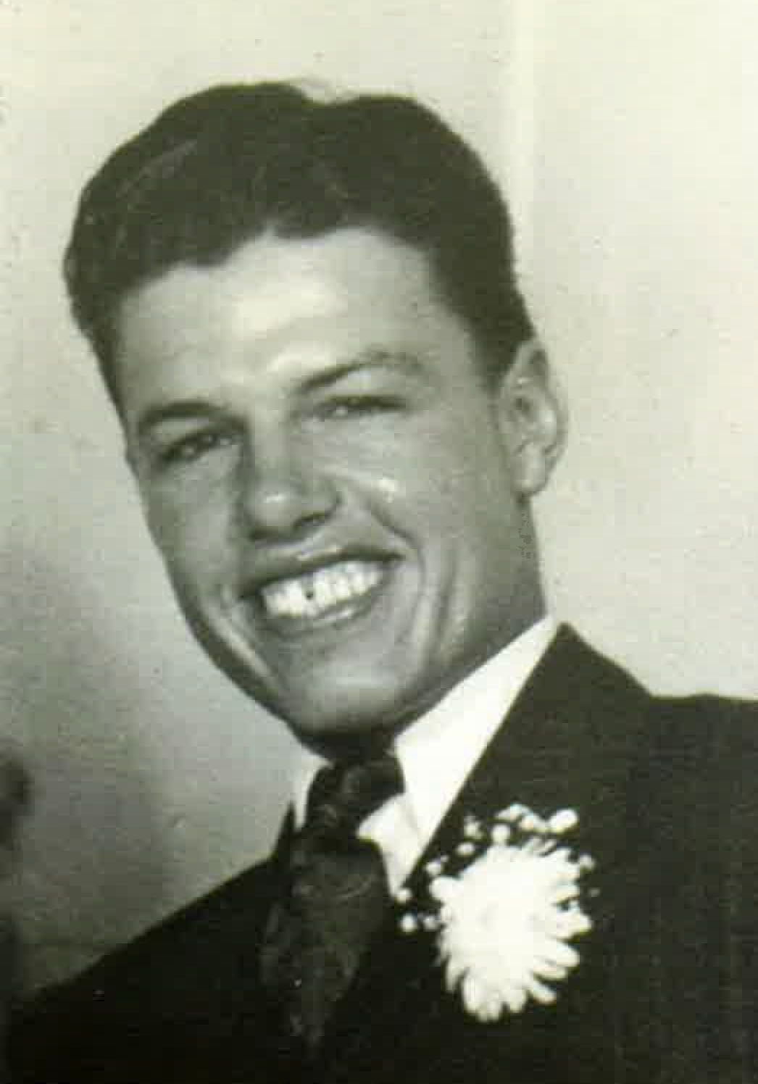
Our family is sad to announce that on June 24th, 2019 at the age of 88 years old, our beloved Murray Ashdown returned to his Heavenly Father surrounded by his family. Murray was born October 5th, 1930 in Cedar City, Utah. He was the son of Leonard and Thelma Ashdown. He grew up on the east side of Cedar City, a.k.a Dog Town as he lovingly referred to it, with his four brothers; Lee, Brian, Laurence and Craig, and sister, Celestia.
Growing up he attended school in Cedar City and worked hard for his family’s livestock company. He met the love of his life, Marketta Phillips of Parowan, Utah in 1948, and they were married on August 27th, 1950. They were sealed in the St George Temple on May 3rd, 1958 for time and all eternity. They were blessed with three sons; Vance, Jeffery and Mark, 10 grandchildren, and 22 great-grandchildren.
Murray loved spending time with his family. He had a kind and giving heart, a mischievous grin that was contagious, a witty sense of humor, a get it done attitude and a love of the Gospel that was unwavering. He enjoyed riding horses, shooting, hunting, but most of all he enjoyed being on the mountain, which always felt like home to him. Murray came from a long line of trail blazing stock. Some of his greatest accomplishments were operating the large cable crane used to set the Blow Hard Tower on Cedar Mountain, constructing numerous bridges along I-15, and starting a construction company in Cedar City that remains in business today. He was a natural born engineer and his favorite thing was working side by side with his sons and family.
He is survived by his wife, Marketta Phillips Ashdown; his three sons, Vance Ashdown, Jeffery Ashdown, and Mark (Cindy) Ashdown; his grandchildren, Jesse Ashdown, Amber Ashdown, Whitney Ashdown, Derek (Erin) Ashdown, Kris (Trish) Ashdown, Mckay (Autumn) Ashdown, Alaena Ashdown; and 22 great-grandchildren.
He is preceded in death by his mother, Thelma Gardner; father, Leonard Ashdown; brothers Brian and Lee Ashdown; daughter-in-law, Linda Ashdown; grandsons, Brennan and Jake; granddaughter, Chyanne; great-grandson, Journey, and many other family members.
Funeral services were conducted today, Wednesday, July 3rd, 2019, at 11:00 AM at the Cedar 4th/14th Ward Chapel (500 W 400 N, Cedar City, UT). Viewings were held on Tuesday, July 2nd from 6:00-8:00 PM at Southern Utah Mortuary (190 N 300 W, Cedar City, UT) and also prior to the funeral services, from 9:30-10:30 AM at the Cedar 4th/14th Ward Chapel. Interment was in the Cedar City Cemetery under the direction of Southern Utah Mortuary. Online condolences can be sent at www.sumortuary.com.

