**SUP Personal Histories**

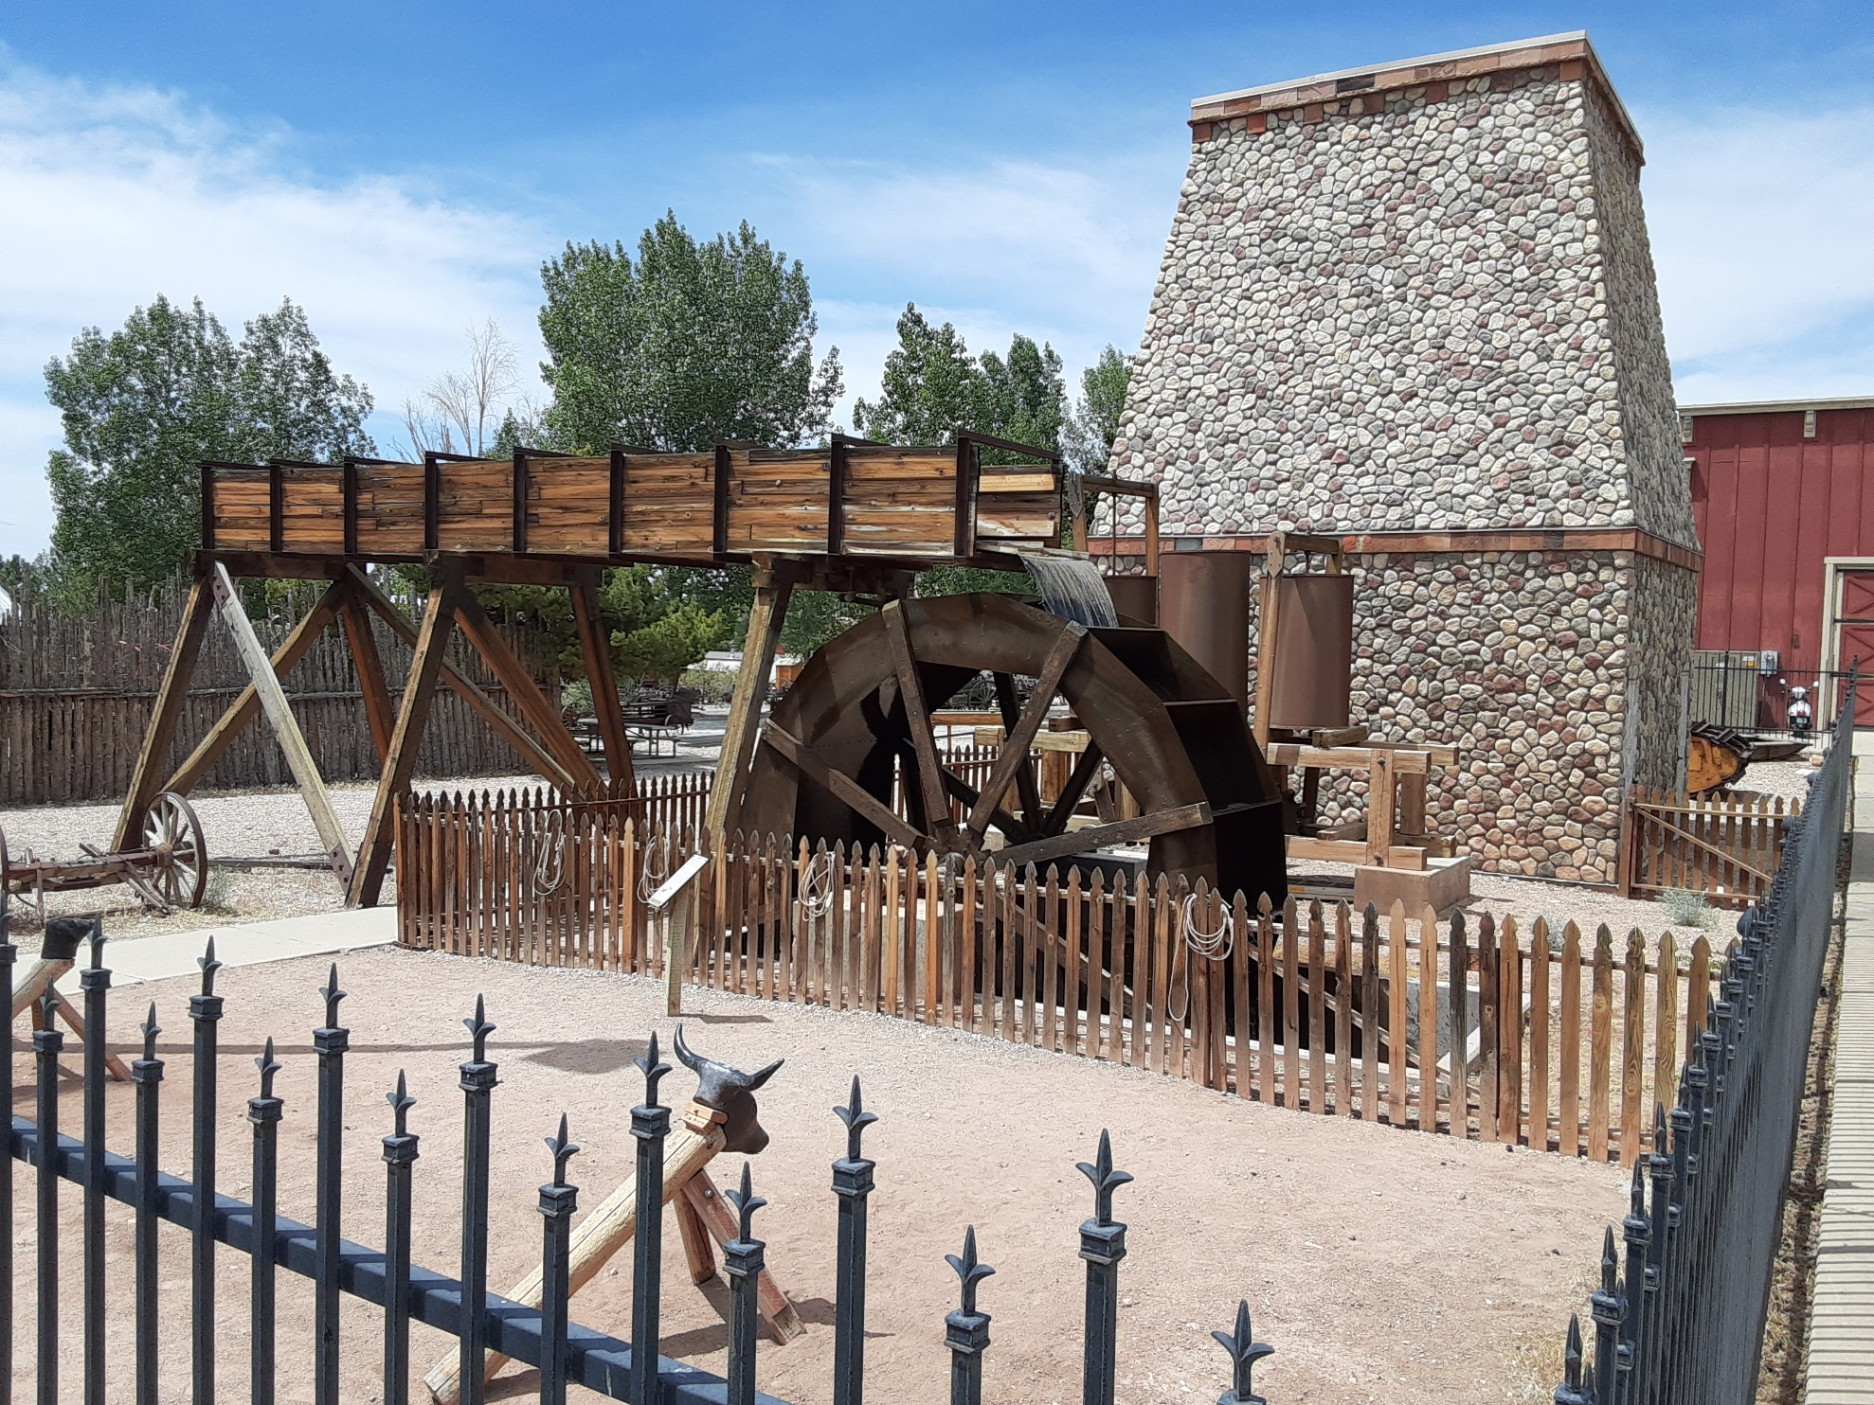

|  |  |  |
| --- | --- | --- |
| **Baldwin, Adrain Ben**  **Blackburn, Charles**  **Bushnell, Van**  **Campbell, Hal**  **Crosby, Jack**  **Felix, Joseph**  **Hair, Cal** | **Kimball, Richard**  **Moss, Carl Lenzi Jr**  **Myers, Kent and Cherie**  **Prestwich, Lyn**  **Shakespeare, Stanley**  **Slack, George Harry**  **Webster, Richard Palmer** | **Talk**  **Liberty, by Lional Kendrick**  **Research**  **Isaac C. Haight, by Elmer Cox** |