**Possible Information Resources**

**For Southwest Heritage Center**

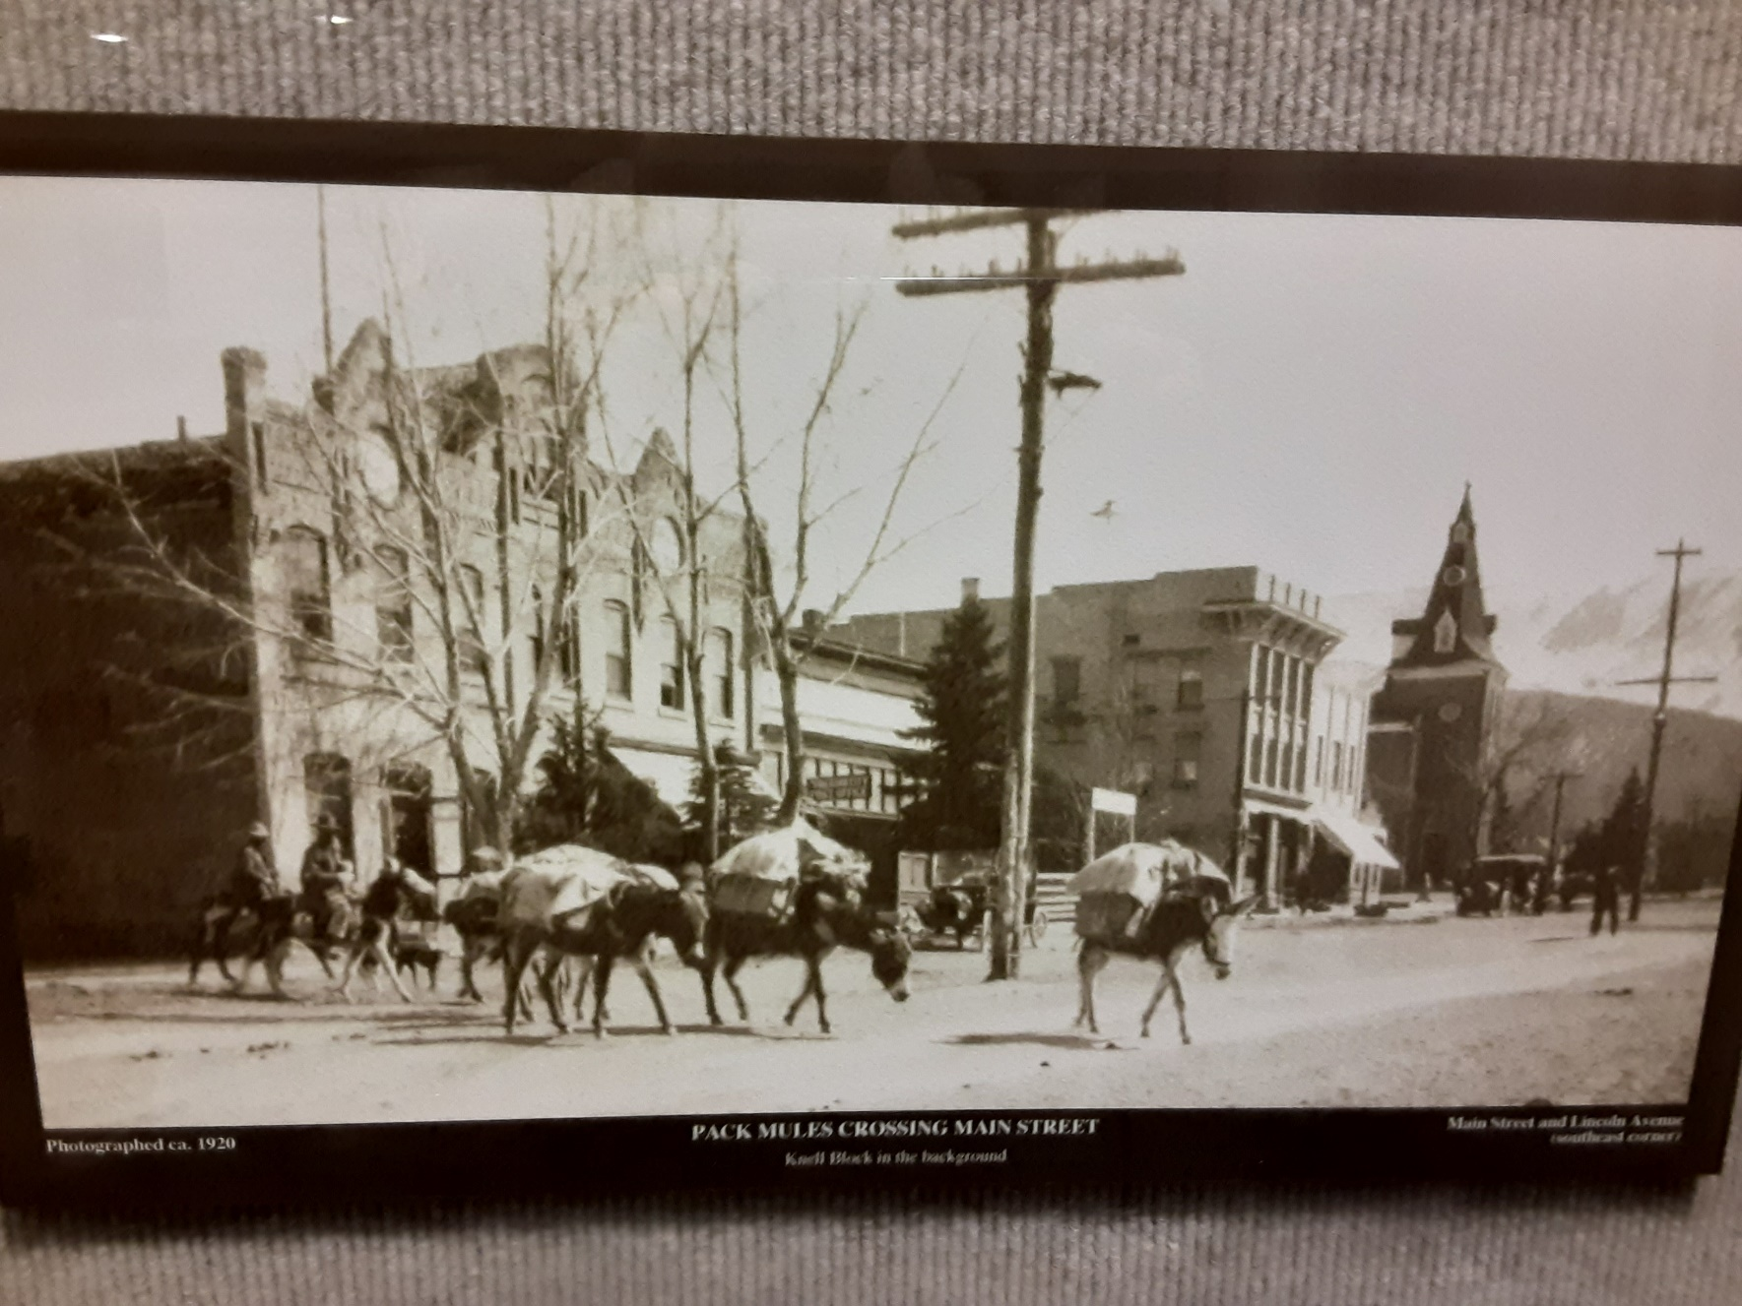

|  |  |  |  |  |
| --- | --- | --- | --- | --- |
| [SUP Histories](SUP_Histories/00_SUP.pdf) | [4th Grade Essays](4th_Grade_Essays/Ancestor_Essays_4th_Grade_2022.pdf) | [Historical Threads](IC_Today/ICT_Index_00.pdf) | [E-Books](E_Books/E-Books.pdf) | [Maps](Maps/Maps_00.pdf) |
| [Veterans](Veterans/Veterans.pdf) | [Iron County Record](Iron_Co_Record/02_Index.pdf) | [Census](Census/00_Census.pdf) | [Character Traits](Traits/00_Traits.pdf) |  |